**West Union Aquatic Center**

**Pooch Plunge 2019**

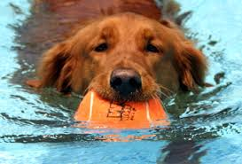

**Consent Form**

OWNER’S NAME:

ADDRESS:

PHONE:

DOG’S NAME: BREED: Age:

BY SIGNING THIS WAVIER, I ACKNOWLEDGE THAT MY PET IS AT LEAST 6 MONTHS OLD AND I AM RESPONSIBLE FOR MY PET AT ALL TIMES. I HAVE PROVIDED A COPY OF MY PET’S VACCINATION RECORD TO THE CITY OF WEST UNION. I UNDERSTAND THAT THE CITY OF WEST UNION CANNOT BE HELD ACCOUNTABLE FOR THE ACTIONS OF THE PARTICIPATING PETS. I HAVE PAID THE $5 FEE PRIOR TO THE EVENT OR $10 THE NIGHT OF THE EVENT.

*Dogs will receive one warning for bad behavior and then may be asked to leave without a refund depending on second offense or severity of initial confrontation. All dogs must be on leash when not in the water.*

SIGNATURE: Date: September 5, 2019